1. **Use case**

Analytics and data science are used in medical technology to predict market trends and enhance patient care. Predicting treatment trends, identifying new healthcare needs, assisting healthcare professionals in making strategic decisions, and creating analytics to assist businesses in anticipating shifts in patient demands are the main uses of these technologies. technology that affects whether a policy is accepted. Healthcare companies can enhance their operational performance by employing data analytics efficiently, according to Mckinsey & Company (2023).

One of the most difficult parts of software development is figuring out the project's objectives. Explain the interactions between different users, who may be people or other systems. A UML case diagram is meant to make system communication easier. Visual aids that show how users interact with a system are called case diagrams. These diagrams are used to determine and evaluate a system's demands.

There are four sections to use case diagrams.   
• Actor: An actor in a use case diagram is any entity that is a part of a single system. This could be an external system, a company, or an individual.   
• System: A rectangle that symbolizes the system defines the use of the case's parameters. The modeling of complex systems is made easier by this optional feature.   
• Use case: A use case is an illustration of how a system works or accomplishes an objective. It is oval and bears a label explaining its use.   
• Relationship: A relationship line shows the relationship between the use case and the actor.

**A case diagram for a healthcare dashboard**

**Use Case Diagram for a Hospital Dashboard**

**The use case diagram for the administrator**

**The use case diagram for the patient**

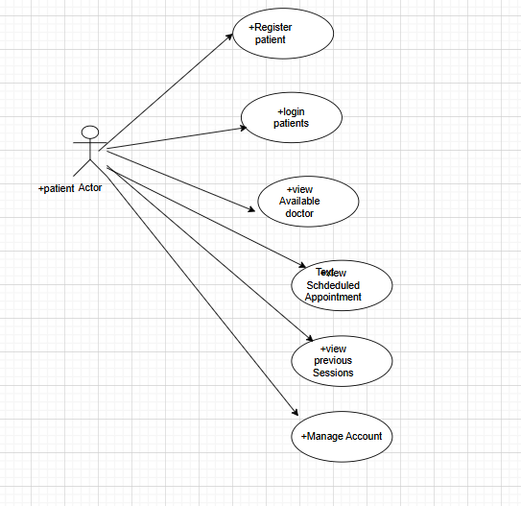

**The use case diagram for the doctor**

